**SoapUI – How to add User Credentials**

1. Download SoapUI from the following link: <https://www.soapui.org/downloads/soapui/>
   1. Make sure to choose **SoapUI Open Source**
2. Open the **exe** file: **SoapUI-x64-*version-number*.exe**
   1. Follow the instructions to install SoapUI. You can keep all pre-selected options and continue to click **Next**.
3. Open SoapUI and click the Import button.
   1. Find the xml file in the SoapUI folder and then click Open.  
      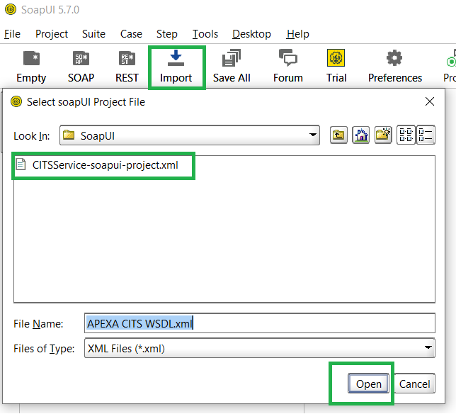
4. Double click on the **CITSService** folder under **My Workspace.**
   1. A window should pop-up.
   2. Click on the **WS-Security Configurations** tab  
      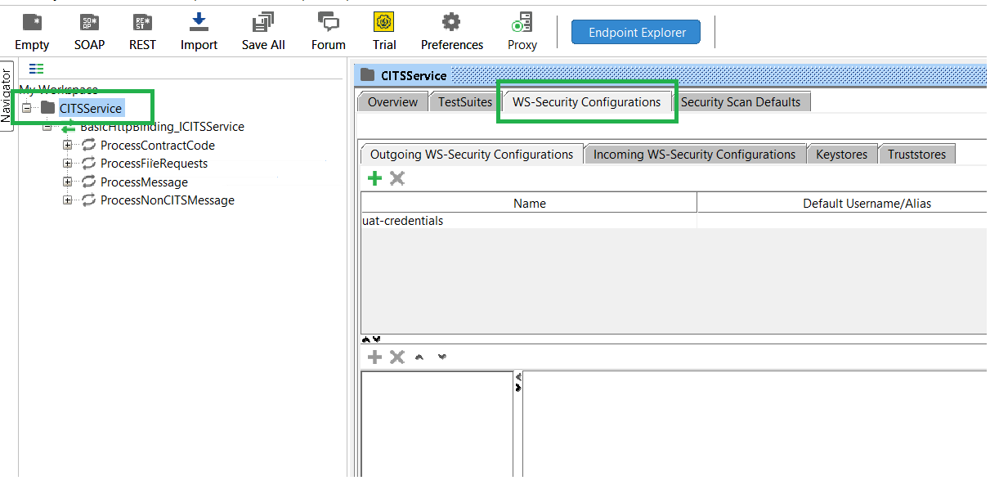
5. In the window above, click on **uat-credentials**.
   1. A new record labelled **Username** should appear in the window below it.
   2. Click on **Username**  
      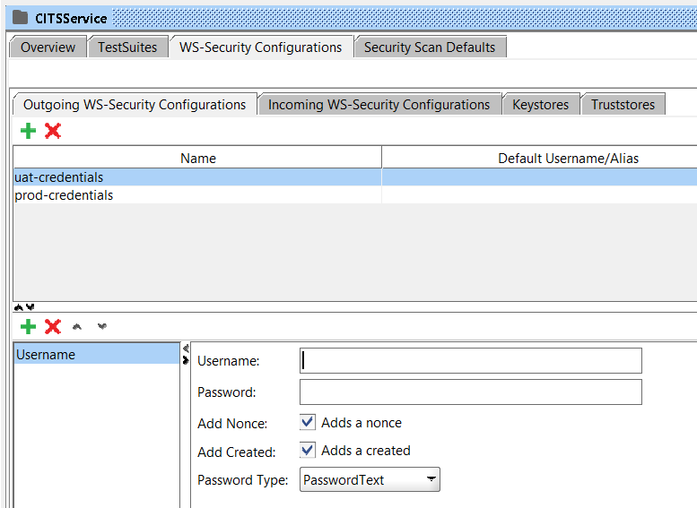
6. Enter your UAT CITS username and password in the provided text fields.
   1. Leave the checked fields checked
   2. Set **Password Type** to **PasswordText**
7. Repeat steps 3-4 for **prod-credentials**, but this time enter your CITS username and password for the production environment.
8. Run the CITS requests in UAT or Production.